Dr.V. R. RENJITH
Professor & Head
Division of Safety and Fire Engineering
School of Engineering
Cochin University of Science and Technology
Kochi- 682 022, Kerala, India.
www.cusat.ac.in,
https://soe.cusat.ac.in/#
https://soe.cusat.ac.in/pages/division/div_fs.php
Mobile No. 9447108856
renjithvr75@gmail.com;renjithvr75@cusat.ac.in
(Former Head of Fire Safety Engineering and Management Dept., International College of Engg. & Management, Muscat, Oman)
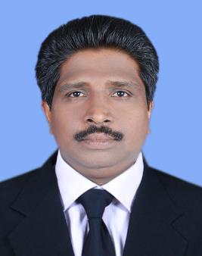

Dr.V.R.Renjith received his Ph.D. in Industrial Safety from CUSAT in the year 2011. His master degree is in Industrial Safety from NIT Trichy (with first rank and gold medal).He has over 24 years of teaching experience in the field of Safety and Fire Engineering. In addition to teaching, he is a researcher, consultant, trainer and quiz master in the field of Safety and Fire engineering. He has published more than 70 papers in international Journals and conferences and prepared 20 consultancy project reports for different industries. He is guest editor and reviewer of reputed journals published by Elsevier (Journal of loss prevention in process industries, applied soft computing, Engineering failure analysis). IEEE access, IEEE systems, Springer, Wiley (Risk Analysis). One of his an article is selected as the most cited article by the Journal of Loss Prevention in Process Industries. He has guided one Ph. D thesis and a dozen students are working under him for their Ph.D. He has guided more than three dozen of master thesis in the field of Safety and risk analysis. His major research interest is to improve the capability of tools used in safety and risk analysis by incorporating artificial intelligence and soft computing techniques. He has developed two Massive open online courses for CUSAT in the field of Safety. He has visited more than 200 industries in India and abroad. He has visited several countries which Includes USA, Singapore, Malaysia, UAE and Sultanate of Oman. He is member of Board of Studies in Safety and Fire Engineering and Chemical Engineering and member of Faculty of Engineering of CUSAT. He is a member of Executive Committee of National Safety Council- Kerala Chapter.

